Dynamic Professional Site Review

By: J. Adam Saenzpardo

# Nicole Allen – ‘Nixie Pixel’

[www.nixiepixel.com](http://www.nixiepixel.com)

**Summary:**

Nixie Pixel is a Linux enthusiast, columnist and hobbyist developer. Her site is easy to follow and summarizes her experience, interests, collaboration and personal projects. It accurately describes her online “influence” with visual representations of her social media platforms and followers.

I realize this page doesn’t use a framework at all, but now that I have two daughters I try and include work complete by both male and female developers. This was my favorite out of the sites I was able to find.

**Dynamic functionality:**

The website is a single page site, so all functionality is on the landing page. She uses lightweight JavaScript for the and additional jQuery paired with a CSS stylesheet for the animations in the “[GeekBeacon”](https://www.nixiepixel.com/" \l "geekbeacon) area of the page. Scalable vector graphics play a role with the page as well.

I should mention the [Font Awesome](https://fontawesome.com/) icon library kit is utilized in the page as well.

The JavaScript library [amCharts](https://www.amcharts.com/javascript-charts/) is used for the interactive chart <https://github.com/amcharts/amcharts4>

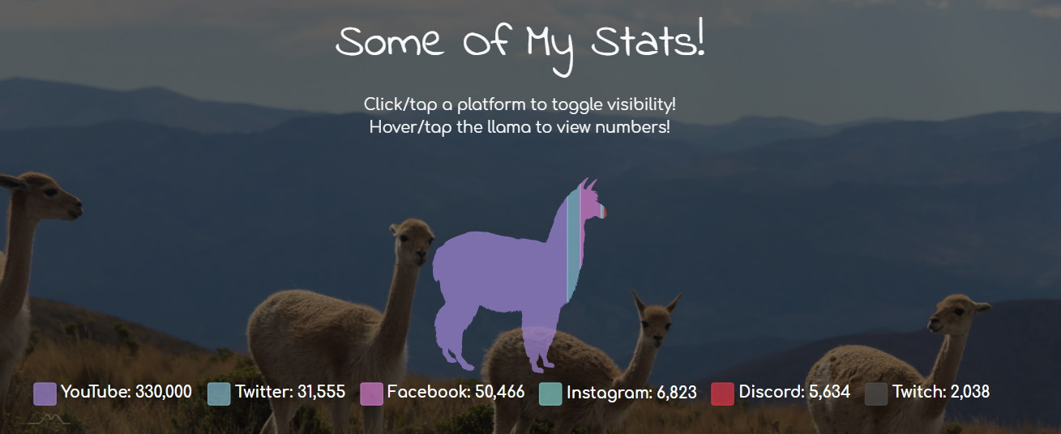

**Navigation:**

The navigation remains fixed at the top of the page and combines social media and “influencer” icons on the right of the page along with appropriate links page sections. The [Comfortaa](https://fonts.google.com/specimen/Comfortaa) font works well here and pairs well with the [Indie Flower](https://fonts.google.com/specimen/Indie+Flower) font used in page headings.

Mobile navigation transitions to hamburger menu that works as expected.

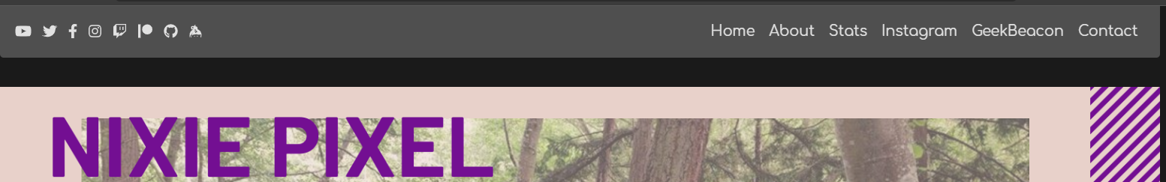

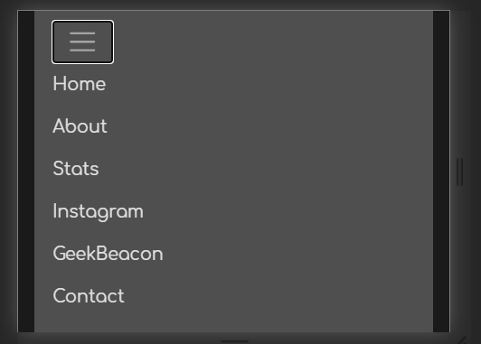

**Grid layouts and framework:**

This site utilizes Bootstrap grids and while the use of a framework isn’t evident, it gives the impression of using a simple framework through the page scrolling and interactive chart. There are columns that utilize flexbox. All others are box model.

The Lodash library is used that provides utility functions for making functional JavaScript easier to implement without knowing all about JavaScript.

**Color Scheme:**

The soft colors make the page easy to read and the accents are in the right place. My eyes are naturally drawn to information the author is attempting to convey. The page is bootstrapped, but it seems to only include the needed classes when inspecting the style sheet. Use of white space is effective and helps my eyes find relevant information.

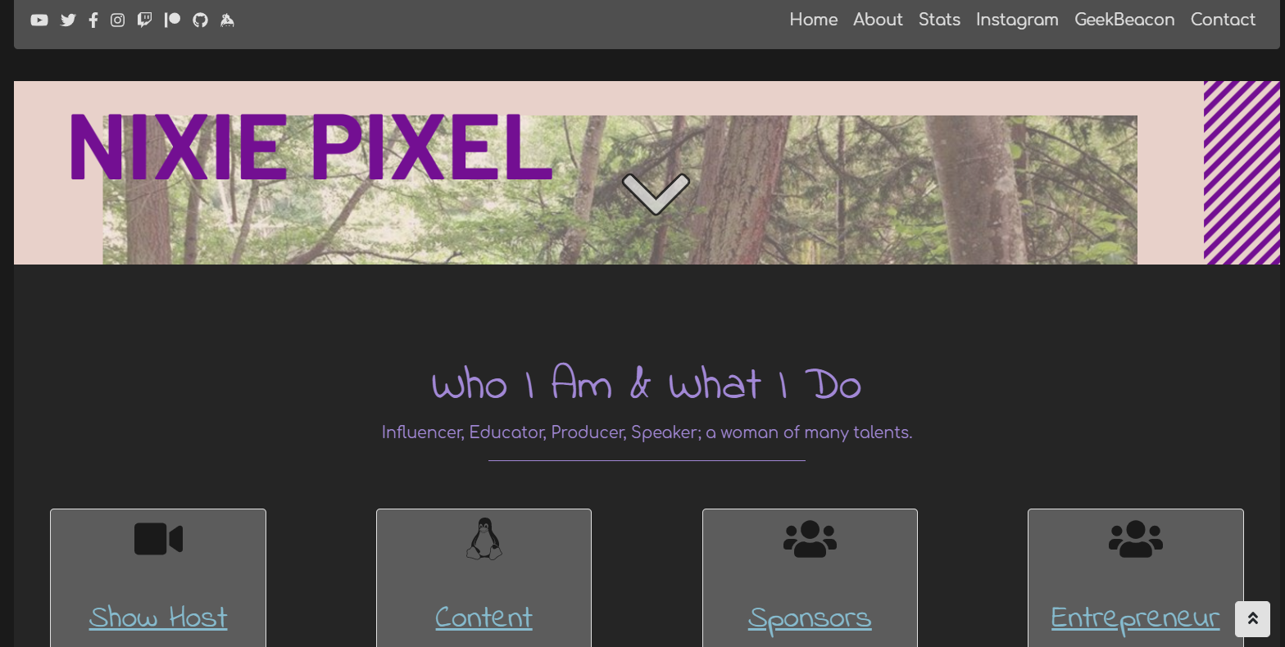

**Professional Content:**

The ‘about’ section clearly displays the information the author want’s you to know. The bordered columns work well while highlighting what the author’s interests are, corporate collaboration, personal projects influence platforms.

**Who is this person anyway?**

While the page doesn’t display personal interests in any type of list, you can tell the author has experience in public speaking, mental health awareness, traveling and an interest in the tech world. The number of followers on popular social media platforms display confidence of the impact you might see if you decide to have the author review something.

# Adham Dannaway

<http://www.adhamdannaway.com/>

**Summary:**

This page is incredibly clever showcasing the author’s artistic designer side and his front-end developer skills. There is are links to articles that have showcased and applauded his design style, portfolios of his work and a link to a blog that hasn’t been updated recently.

**Dynamic Functionality:**

There is impressive JavaScript and jQuery being used throughout the landing page and subsequent pages. See breakdown below.

Home Page:

The clever separation between designer and coder reveals the artistic side and front-end abilities. There’s a seamless transition between the artwork and image backgrounds. It takes a bit to load the page entirely, but moving the mouse to the coder side of the page also fades out the designer portion and vice versa.

About Page:

The way the thumbnail photos and pie chart pop up are clever and grab your attention. The bar chart values bouncing up are also well presented.

Featured Page:

The way the pictures “slide” into the articles is a neat touch.

Portfolio Page:

Increasing of the opacity of all thumbnail images in the portfolio page is clever. Opacity is at 1 for all elements. When you hover on any thumbnail all others move to 0.4 opacity.

**Navigation:**

The navigation bar is effective and intentions are clear where the link will take you. The navigation icons cover email, social media and dribbles. Navigation menu collapses into a hamburger menu for mobile and works flawlessly.

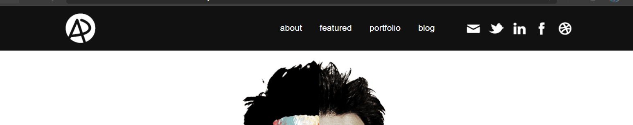

**Grid Layout and Frameworks:**

Use of box model is apparent and the styling is completely custom. There is no evidence of flexbox or CSS grids. There is a lot of dynamic functionality using jQuery. This site does utilize the WordPress library/framework (I’ve discovered if you don’t use WordPress, it’s a library. If you do use it, it’s a framework) and it does appear to be properly implemented.

**Color Scheme:**

The author take a simplistic approach to the color scheme using a distraction free black and white method that is well implemented. I generally shy away from solid backgrounds, but this works. Other pages on the site follow this color scheme and it has a modern look and feel. White space draws my eyes to the information and helps it flow in a natural manner.

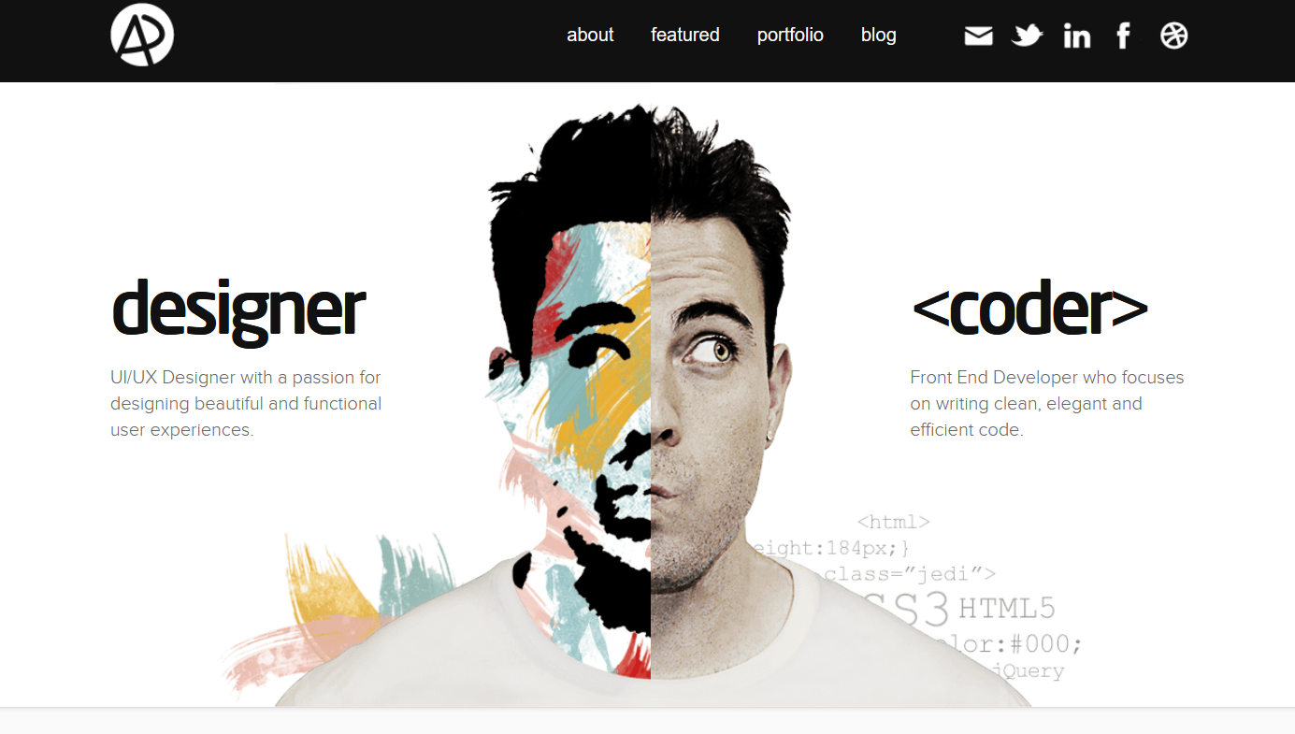

**Professional Content:**

The author is confident in presenting the skills that accompany a developer that clearly prefers the design side of the job. There are easy to follow visual aids that also bring about the author’s sense of humor and sarcastic personality.

**Who is this guy?**

The author seamlessly integrates personal interests along with what his preferred line of work is. I get the impression this guy can work through complex JavaScripting and create attractive user interfaces that work well. He has discusses personal hobbies and seems likeable.

# Rafael Caferati

<https://caferati.me/>

**Summary**

This was one of the only pages I was able to find that was a top-to-bottom complete web application using the React framework. Author is a full-stack developer and displays skills very well. It’s clear the author doesn’t need to showcase skills in a list to get your attention. Clicking the button at the bottom of the page enters an interactive “Gattaca” style game to destroy the web page text. The application is very intuitive and you don’t need to hunt for information.

**Dynamic Functionality:**

The site is a React web application, although my browser didn’t pick this up. There is also a banner in the upper right corner that links to his react-awesome-slider application and a link to his repository showcasing this.

The page appears to “flip” the side of a cube to show the portfolio page, code laboratory and contact pages. Each page has similar effects that showcase the transition from one page the to next.

**Navigation:**

The navigation is what I would consider non-standard. There’s a hamburger menu that expands into a linked navigation menu. This is searchable if you just start typing, but you have to match existing tags and it loses functionality if you don’t reload the page.

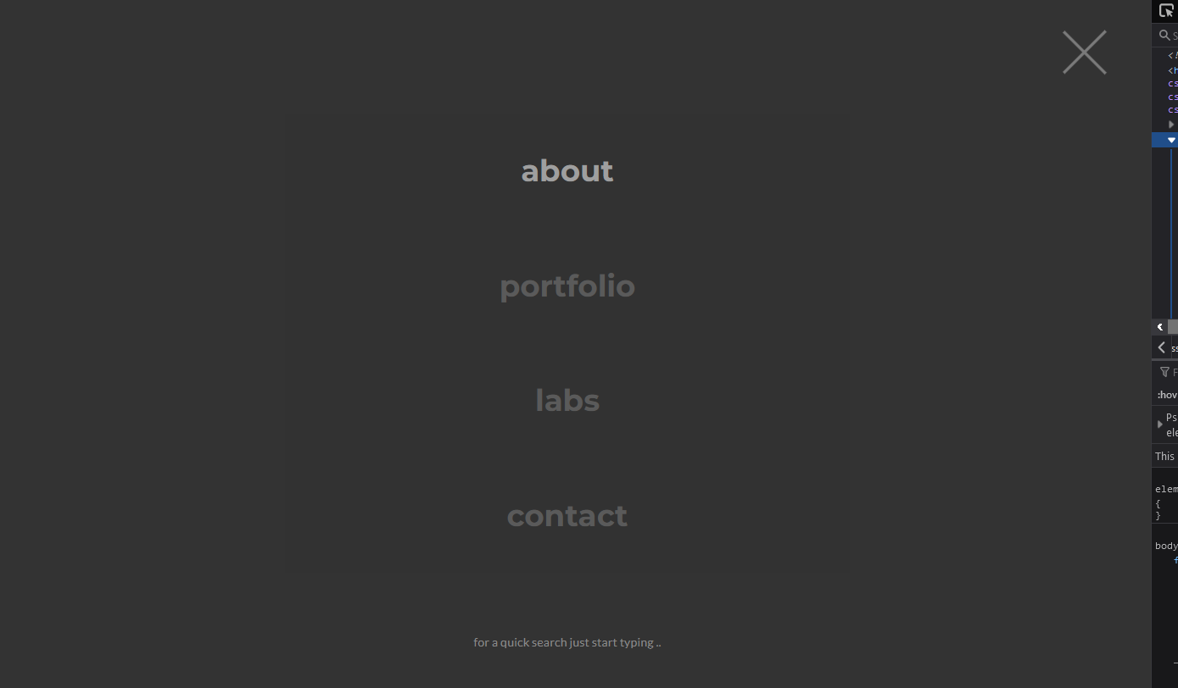

There is also easy to follow navigation on all pages. There is a “slideshow arrow” that transitions from one page the next and there are “buzz-word” links that make pages easy to navigate.

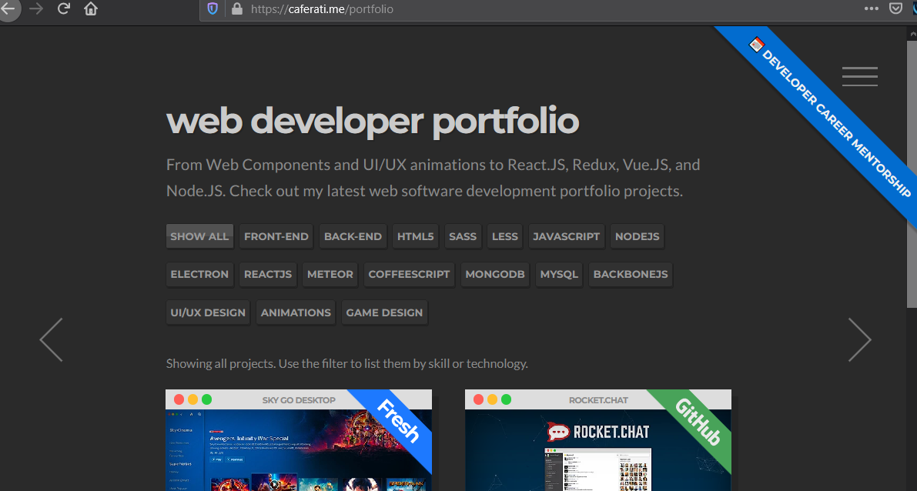

**Grid Layout and Framework:**

The browser detects box model, but since this is a React application, I’m not sure if a third-party library was implemented for grid control. I know it’s possible to include additional grid libraries that might not be obvious after the production build is deployed.

The framework is well implemented, and the author is clearly a knowledgeable front-end engineer.

**Color Scheme:**

The color scheme is simple with a dark gray background and lighter gray font. This color scheme is pleasant to my eyes, but as with my personal site, it does cause contrast issues when running accessibility tests.

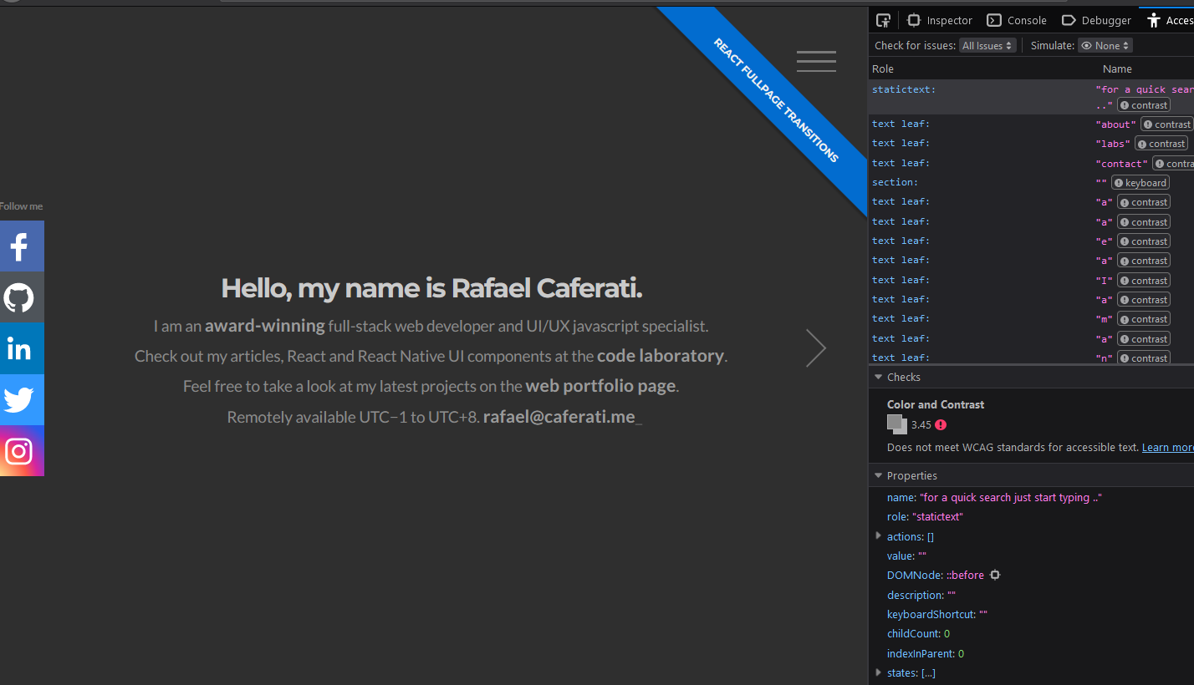

The use of white space is affective. The bland site draws your attention to the center of the page and the way the text appears to “chisel” into the page works well. The level of simplicity is arrogant, but he knows the audience, knows how to get attention and achieves it while showcasing raw skill. I was very impressed with this site.

**Professional Content:**

The content displayed is professional in nature and easily showcases the author’s ability to implement desirable content into a full-stack web application. The labs section contains well written articles with code snippets explaining the item in question

**Who is this person?**

There is no personal information available on the site, but I get the impression that the author is articulate and well educated. Information is effectively conveyed and links to social media platforms are available.

# Matthew Williams

<http://findmatthew.com/>

**Summary**

Author is a full-stack web developer and this is clearly stated on the homepage with a large transparent pill button moving the page along. The author isn’t shy showcasing where his passions lie and enjoys creating fast and dynamic web applications.

**Dynamic Functionality:**

Material design components are used at the pill button landing page, navigation bar, projects area blog, contact area and footer. It’s enhanced with jQuery and functional JavaScript

jQuery is used for the ajax POST method to work with a JSON file as shown below. I found this interesting because I never noticed where or how it was implemented other than a couple of tutorials I’ve viewed.

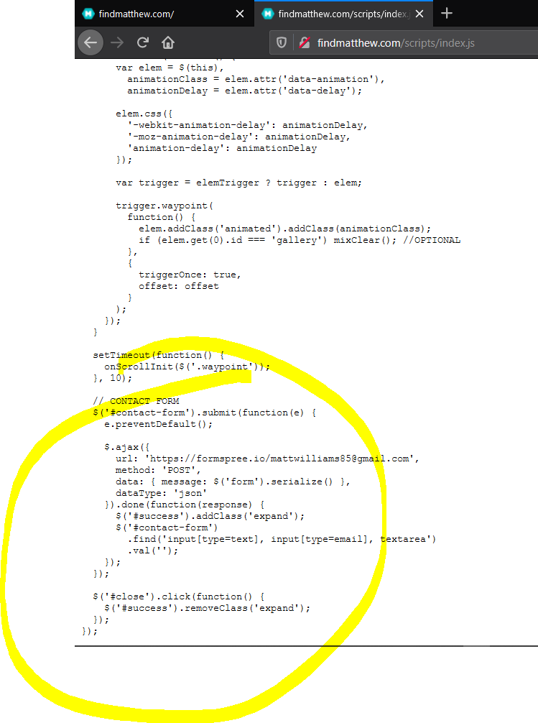

JavaScript is used throughout the page and the author leans heavily on it for use of the modal and bar chart.

There’s a very clever background animation that utilizes custom JavaScript. The “meteors” in the background continuously rotate and are highlighted on mouseover. Script file is [here](http://findmatthew.com/scripts/canvas.js) and I may modify this for my asteroids page. It’s unique and give a retro-modern touch.

**Navigation:**

There is no immediate navigation that is apparent on the landing page. This goes against standard conventions, but the “distraction free” landing page makes it work.

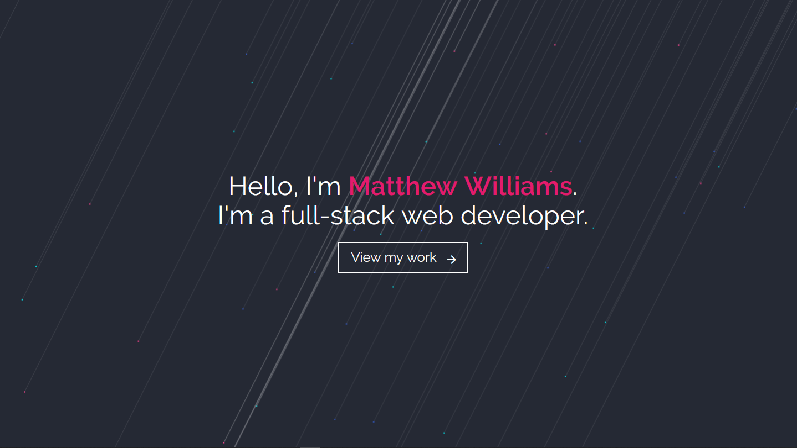

After moving along a navigation menu presents itself with no external links. The navigation bar works well with transition effects that fade when in you hover a link.

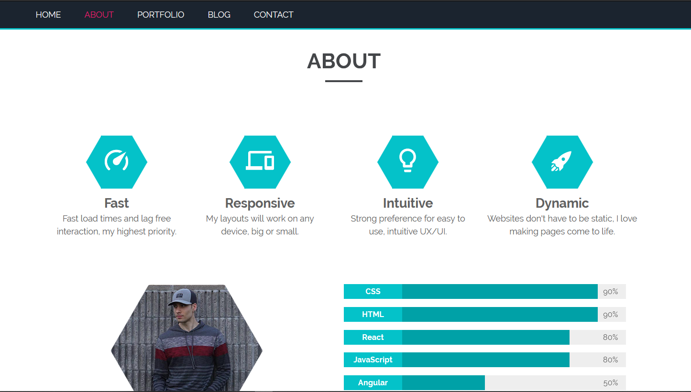

The portfolio area introduces a modal to see more about the work completed.

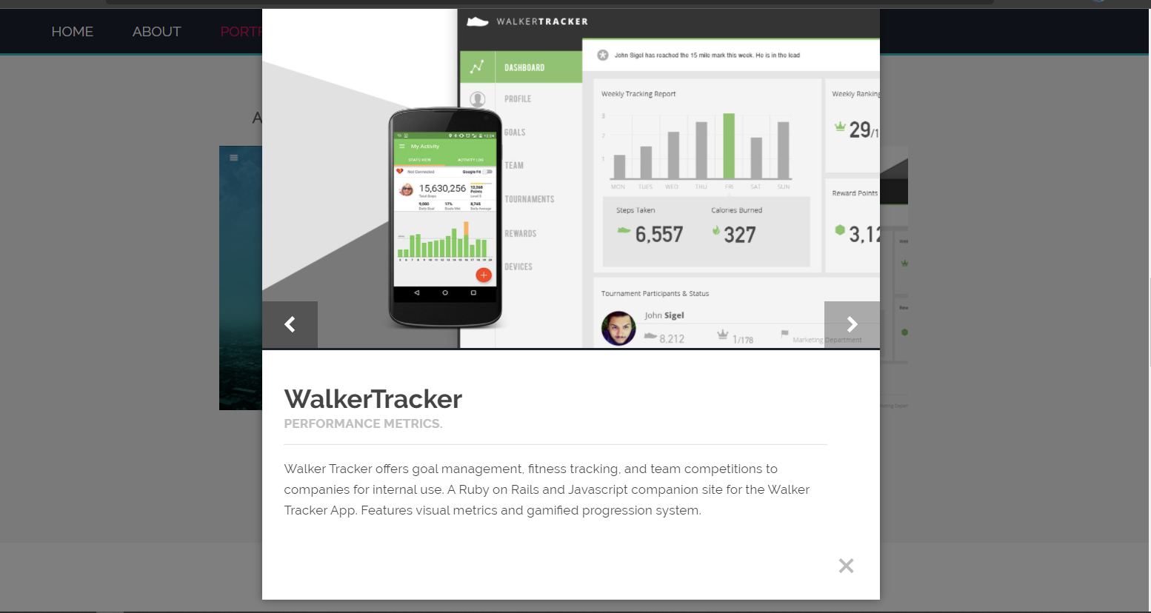

**Grid layout and Frameworks:**

This page implements the Material Design framework and it uses a similar grid system to Bootstrap. Column-variate grid system with breakpoints for desktop, tablet and phone.

**Color Scheme:**

The landing page and bottom contact area nicely blend a dark background with lighter text. The rest of the page uses a white background while the icons and bar chart stand out with a nice shade of cyan. The slightly gray project background separates the page sections nicely.

Use of whitespace enhances the page layout and draws attention to content without forcing it.

**Professional Content:**

The authors areas of interest are well showcased and past projects highlight the capabilities of the developer. Although the blog pages are interesting, they haven’t been updated recently. The posts do show the developer is intelligent and has no trouble distributing his thoughts to paper in a manner that’s easily understood.

**Who is this guy?**

Like the last page, the author doesn’t share much about his personal life or interests. There are social media links at the bottom of the page that are current. The developer appears to be currently involved on projects and professional.

# Josue Espinoza

<http://ejosue.com/>

**Summary:**

This site caught my attention right away. The author is a software engineer and makes good use of a blurred code editor background. The author is a self-proclaimed software expert and this site is designed as a portfolio.

**Dynamic functionality:**

Like several other pages I’ve researched, this one uses jQuery, JavaScript and JavaScript libraries. There is a [GreenSock](https://greensock.com/) plugin that’s very interesting and it looks awesome. The code can be found [here](http://ejosue.com/wp-content/themes/salient/js/tweenmax.min.js?ver=1.18.0).

WordPress content management system is implemented in this site as well. The contact area is a form submission that looks to be auto-generated by WordPress. The variable names don’t seem to be conventional names a person would use. <http://ejosue.com/wp-content/plugins/contact-form-7/includes/js/scripts.js?ver=5.2>.

**Navigation:**

The site utilizes a standard hamburger menu that’s easy to recognize.

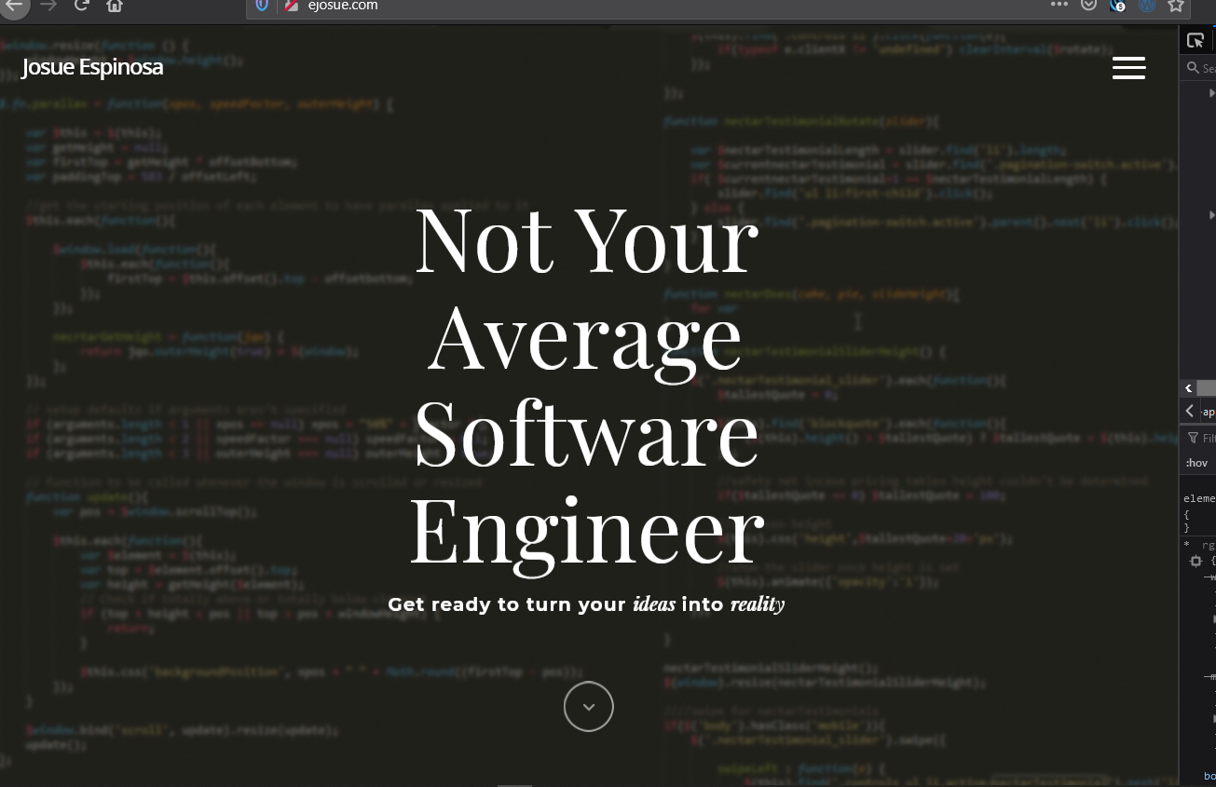

When clicked, it takes over the landing page that includes links to all pages and social media icons.

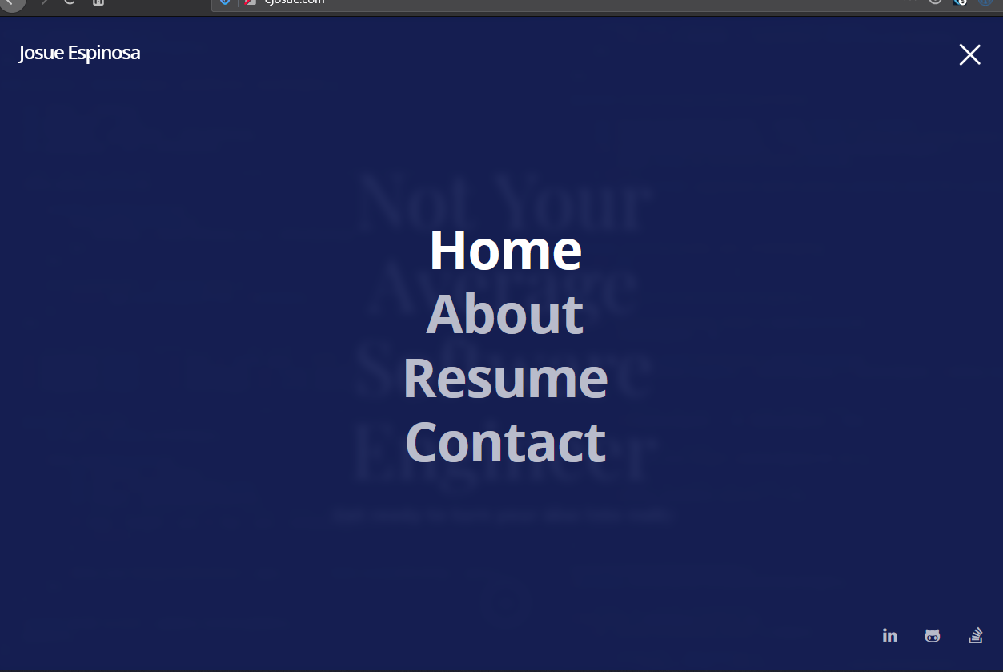

What I find really cool is clicking the bottom arrow or rolling the mouse wheel activates an animation that “rolls” to the next page. Although, this animation is resource heavy and when I have three different browsers open with multiple tabs on each I can see it struggle a bit.

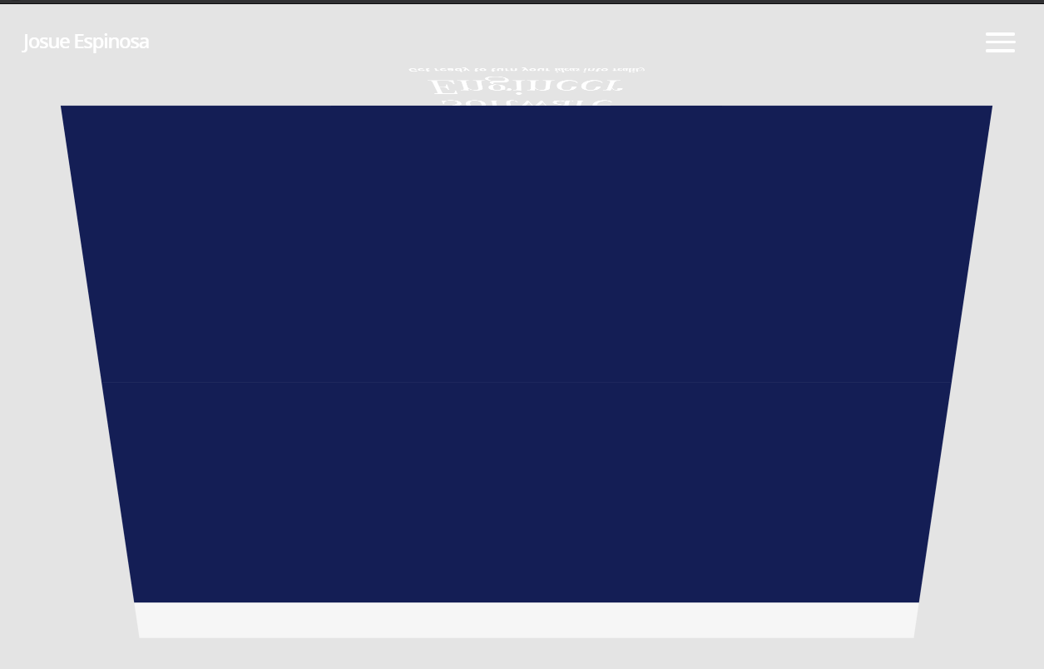

**Grid Layout:**

It appears the standard box model is utilized and as mentioned earlier, the WordPress library is used.

**Color Scheme:**

The color scheme works well utilizing high contrast colors that mesh well with each other. The backgrounds in the ‘Case Studies’ area creates excessive noise and my eyes have trouble naturally tracking the information being presented. The font in this area doesn’t collapse well and the columns would be better suited without the backgrounds.

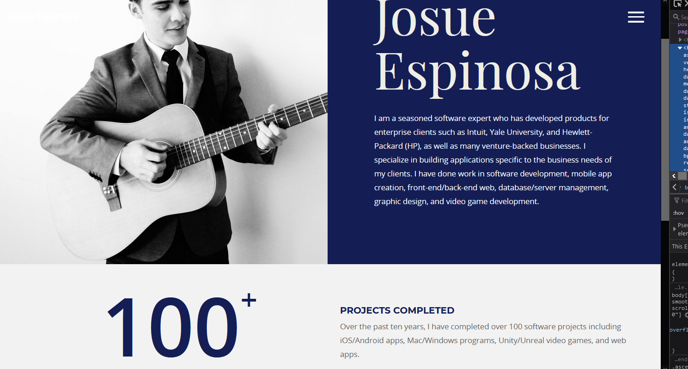

The color scheme in related pages are all similar. Use of whitespace doesn’t seem to have been a thought and it could contribute to the site if implemented properly. Particularly in the ‘Case Studies’ area.

Comment on professional content being presented

Content is delivered to the user in a manner that’s easily understood. The “about me” section discusses content that a recruiter would understand and it gives a good understanding that the author appears capable.

What personal information is shared and do you get a good sense of the who the person is.

Very little personal information is displayed and the links to social media networks are all professional in nature. I can’t gage the users personal interests or hobbies from the information provided.

# Summary:

I researched several sites and it was difficult to find that sites that implemented a framework. I was looking for the CDN links to Vue, React, Angular, etc. I think I’ll add a little shoutout in the top comments of my code specifying <!-- This was created using Vue! --> Or something along those lines.

I definitely want to implement a form of the “coding laboratory” that [www.caferati.me](http://www.caferati.me) used [here](https://caferati.me/labs). This is similar to what I was already planning for the code playground area on my page.

I also want to get the “newsletter” signup area working and I’ll try to implement this using PHP and MySQL in cPanel. I need more research here. I searched it some, but I mostly get plugins. I want a tutorial that will teach me to write the code and security best practices that should be followed.